1. Write a program to imitate the calculator. Use *switch case* statement.

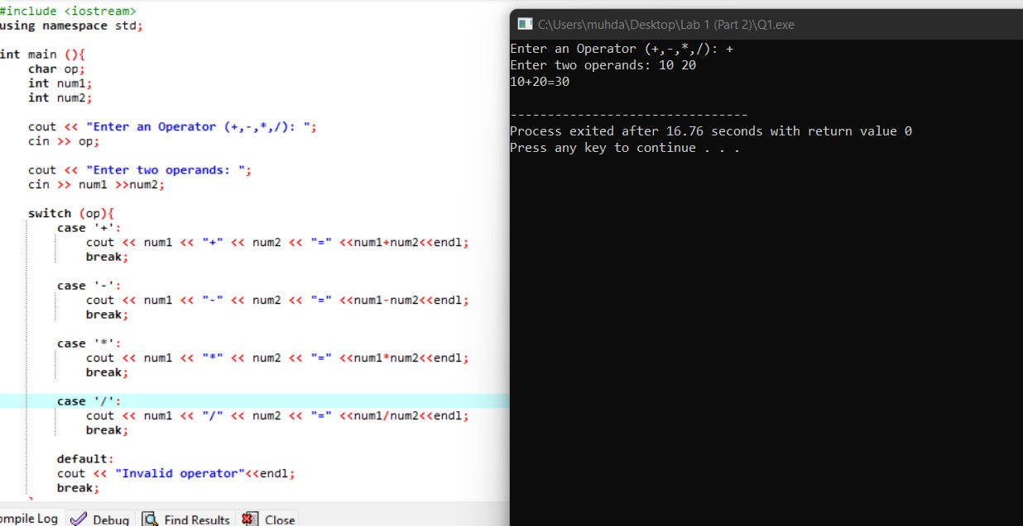

1. Write a program to produce the following pattern. Use nested loops.

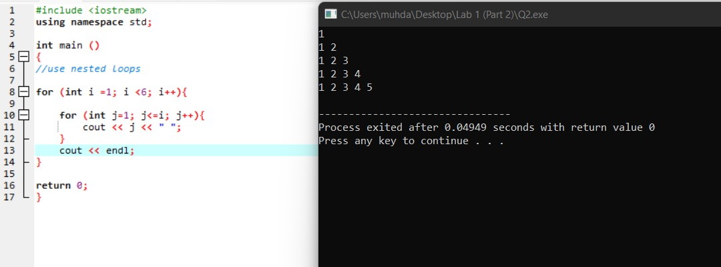

1. A class of five students took a quiz. Write a program that will prompt the user to enter five student’s marks and calculate the average quiz marks. Use while loops to prompt all the five marks.

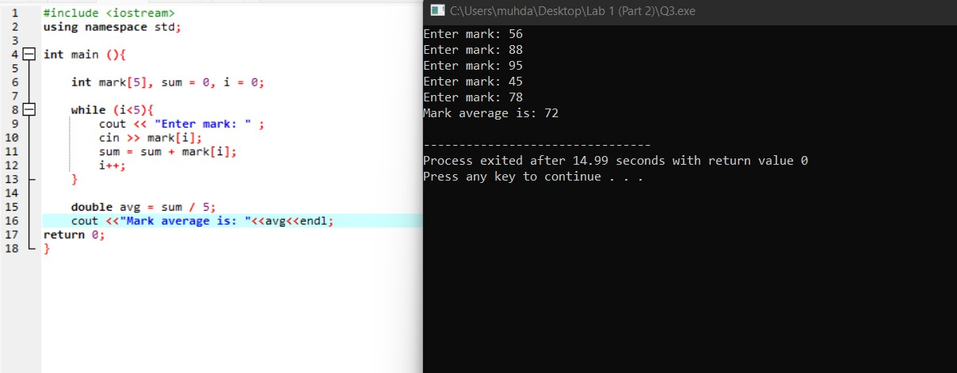

1. Prompt user to key in five integer values and store the values in an array. Pass the array to a function name Sum( ) that will calculate and display the sum of all the elements.

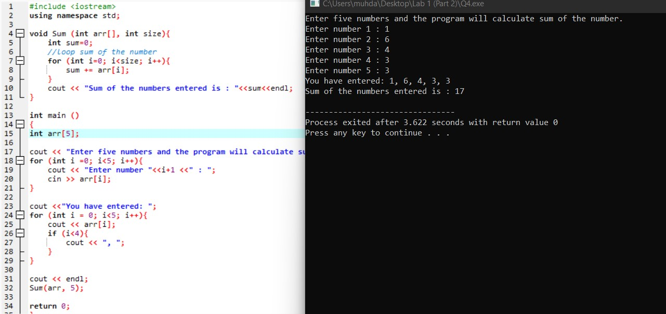

**Submissive Question**

Create a struct called employee. Members of the struct will be first_name type string, last_name type string, emp_num type string, and age type int. Create an instance of the structure called record to access the members of type employee.

